CONTENTS

COCKTAILS ON TAP

- Dispense Set-up Page 1
- Lines Page 2
- Gas & Pressure Page 2
- Delivery Dates & Methods Page 3
- The Cocktails Page 3
- Keg connecting & Disposal of Empties Page 4

INFORMATION

- Dispense set-up
Dispensing cocktails has similarities to dispensing lager; the only real difference is that it’s a cocktail! Below is a basic drinks dispense diagram showing how to install a single point of draught/keg wine/ beer / cocktail on a typical UK set-up.

- The GAS or air goes primary valve secondary valve into the side entrance of the keg connection/coupler.
- The COCKTAIL runs from the keg cellar buoy to the inlet of the cooler from the cooler into the wine tap.
There is usually a flow controller between the outlet of the cooler and wine tap to adjust how fast the wine is poured.

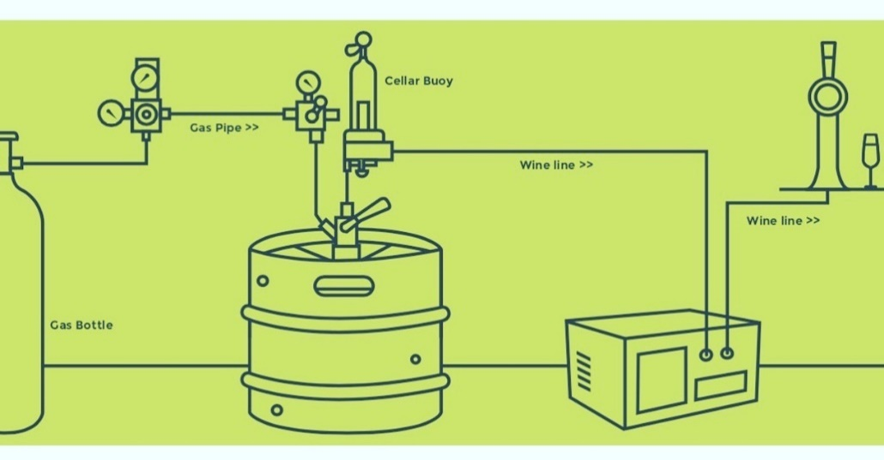

- Lines
The line length is very important for wastage and fizz, we recommend the following:
- Optimal length = 2 metres
- Satisfactory length = 5 metres
- A gas pump on much longer lines would be beneficial albeit, lead to wastage.
- Thickness 3/16
It is recommended that you clean your lines with line cleaner every 7-10 days.

- Gas & Pressure
Pressure Types
- KeyKeg Co2, Mixed Gas or Air

The pressure can be set at 1.2-2.0 bar/ 17.4-29PSI. It can use Co2, Air or mixed gas - they come in a Keykeg so no pressure will contact the drink.

- Delivery Dates & Methods

The cut-off point for Next Day delivery is 12pm for parcels and 10am for pallets. The standard delivery charge is £8 per keg. (capped at 5 kegs.)

- Parcels for less than 6 kegs
- Pallets for more than 6 kegs

- The Cocktails
MOJITO 10% (rum) - serve over ice & add soda: A sweetened blend of flavoured citrus juices and white rum.
Flavour: Fresh lime with distinct rum flavour and strong mint nose.
Contents: 50ml alcohol per serve / Water Rum, Lime Juice, Lemon Juice, Natural Mint Flavour, Colour: Clouding agent, Preservatives: Potassium Sorbate, Sodium Benzoate.
Size: 20 litres / 133 servings at 150ml

PINK GIN FIZZ 10% (gin) - serve over ice: A sweetened blend of flavoured citrus juices and London dry gin
Flavour: Fresh lime with distinct gin flavour and a hint of berry flavour.
Contents: Water, gin, lemon juice, sugar, propylene glycol alginate, natural flavourings, preservatives (potassium sorbate, sodium benzoate), colour (anthocyanin).
Size: 20 litres / 133 servings at 150ml

PASSIONFRUIT MARTINI 10% (vodka) - line to be connected to cooler: A sweetened blend of flavoured fruit juices and vodka
Flavour: Tarte passionfruit with sweet mango and characteristic vanilla vodka nose.
Contents: 50ml alcohol per serve / Water, Vodka, Passionfruit Juice (10%), Sugar, Mango Puree, Lime Juice, Orange Juice from concentrate, Acidity regulator: Citric Acid, Salt, Natural flavourings, Colour: Carotenes, Preservatives: Potassium Sorbate, Sodium Benzoate.
Size: 20 litres / 133 servings at 150ml

PINA COLADA 10% (rum) - line to be connected to cooler: A sweetened blend of flavoured fruit juices and white rum
Flavour: Sweet pineapple and coconut flavour with distinct white rum taste.
Contents: 50ml alcohol per serve / Water, White Rum, sugar, SKIMMED MILK, fruit juices from concentrate (pineapple, coconut, lemon), CREAM, stabiliser: natural pectin, Acidifier: lactic acid, natural flavourings, preservatives: potassium sorbate, sodium benzoate, Acidity regulator: trisodium citrate
Size: 20 litres / 114 servings at 175ml
Fresh: 4 weeks once opened. Store at an ambient temperature.

- Set-up and Disposal of Empties
Visit https://www.keykeg.com/en/demonstration-videos or download the information at https://www.keykeg.com/en/downloads to learn how to set-up and dispose of your keykegs.

For more information call or email us.

[End of Document]

