The purpose of this document is to provide further information on The Sparkling Wine Co’s ONTAP products including useful hints.

CONTENTS

WINE ON TAP
- Dispense Set-up Page 1
- Lines Page 2
- Gas & Pressure Page 2
- Temperature Page 3
- Branding Page 3
- Glassware Page 3
- Delivery Dates & Methods Page 4
- The Frizzante Wine Source Page 4
- Keg connecting & Disposal of Empties Page 5

INFORMATION

- Dispense Set-up

Dispensing sparkling wine has similarities to dispensing lager; the only real difference is that it’s wine! Below is a basic drinks dispense diagram showing how to install a single point of draught/keg wine or beer on a typical UK set-up.
- The GAS or air goes primary valve secondary valve into the side entrance of the keg connection/coupler.
- The WINE runs from the keg cellar buoy to the inlet of the cooler from the cooler into the wine tap.
There is usually a flow controller between the outlet of the cooler and wine tap to adjust how fast the wine is poured.

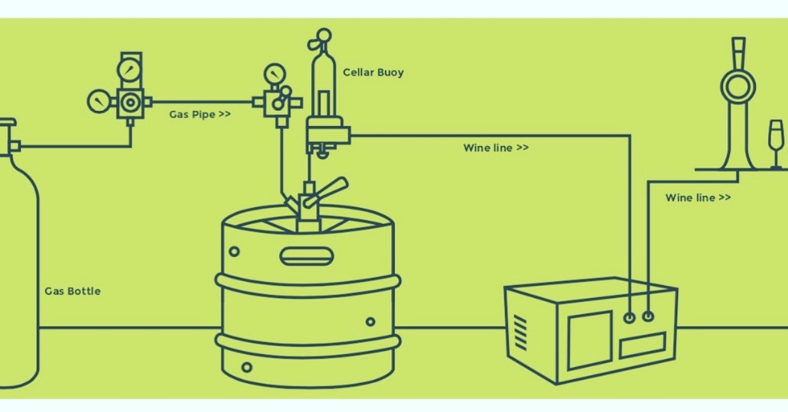

- Lines
The line length is very important for wastage and fizz, we recommend the following:
- Optimal length = 2 metres
- Satisfactory length = 5 metres
- A gas pump on much longer lines would be beneficial albeit, lead to wastage.
- Thickness 3/16
It is recommended that you clean your lines with line cleaner every 3 weeks. For the cleaning you'll need a pressurised bottle (small keg) with the appropriate connector. It then will connect like a wine keg would. Obtain a pressurised cleaning bottle with an S type / Sankey fitting (5 litre will do) and a key keg cleaning socket to connect to the top. This will allow you to put the existing Keykeg coupler you have on the cleaning bottle. (OR buy a Sankey coupler) We suggest the following websites for products:
Cleaning Bottle: https://www.ewlonline.co.uk/cleaning-bottle-5l-sankey-45psi
Cleaning Connector: https://www.keykegshop.eu/cleaning-adapter-keykeg-g-to-sankey-s-system-with-lever-european.html
Cleaning Chemicals: https://www.chemisphereuk.com/shop/beverage-dispense/

- Gas & Pressure

Pressure Types
- Polykeg Co2 only
- KeyKeg Co2, Mixed Gas or Air
The maximum dispensing pressure is 3.5 bar / 51 PSI. The safety valves on every coupler prevents higher dispensing pressures.

- Temperature

The ideal serving temperatures can be found at http://thesparklingwine.co.uk/product-category/wine-on-tap/Check each wine description for full details.

- Branding

The Sparkling Wine Co. will provide circular 82mm badges for your fonts.

- Glassware

We recommend using glassware which will preserve the fizz - with any sparkling wine whether lightly sparkling Draught or bottled fizz glassware should be invested in and regularly checked. Here’s some information we recommend.
How can the ‘fizz’ in sparkling wine be preserved? Thanks to modern innovation, EFFERVESCENT POINTS act to improve the stunning presentation and the longevity of fizz. These points are laser etched on the inside base of a glasses bowl.
These six points help to encourage the gas to separate out at the base of the bowl, which in turn causes the bubbles to spiral upwards through the full length of the wine in the glass. This motion enhances the overall presentation while prolonging the lifespan of the fizz.
Via our partner Wineware.co.uk try the Congresso range from Schott Zwiesel click https://www.wineware.co.uk/schott-zwiesel-congresso-champagne-glasses-flute-set-of-6
Use discount code "SPARKLINGWINECO" for 15% off

Or, for Plastic glassware try Party Plastics https://www.partyplastics.co.uk/default.aspx
Equally you can adapt your own glassware with a glass etching tool (a neat and inexpensive tip). This will work in a similar manner to a widget in beer glass.

- Delivery Dates & Methods

The cut-off point for Next Day delivery is 12pm for parcels and 10am for pallets. The standard delivery charge is £8 per keg. (capped at 3 kegs.)

- Parcels for less than 6 kegs
- Pallets for more than 6 kegs

- The Frizzante Wine Source

Region Veneto (N.E Italy) within the Treviso province or 1 hour from Venice Veneto is the only region in the world which can produce prosecco (like champagne region)
The Frizzante Wine Prosecco grape is Glera, which is something that can be grown in other countries with a similar climate, however, not able to call it prosecco when kegged due to the Italian law. Frequent winners of awards within the region. Produced in the vines of Marca Trevigiana the glera frizzante is particularly fruity, slightly aromatic & rounded sparkling wine. 11% alcohol.
Production Rather than Champagne which it's secondary fermentation method takes place in the bottle, prosecco is fermented within stainless steel tanks. However, DOCG prosecco's must have their secondary fermentation process within the bottle. The wine is kegs will have it's secondary fermentation method within the steel tanks and any DOC's.
Write up for the kegged wine Sparkling wine obtained by means of the charmat method, produced with grapes harvested in our vines Veneto. Particularly fruity, slightly aromatic, rounded, it is perfect as an aperitif, for use in cocktails.
The keg itself:
- Under pressure of 3 bar.
- Shelf life opened is 4-6 weeks and unopened 9 months from filling.
- KEYKEGS do not allow air to contact with the wine (Sparkling and Still kegs)
- POLYKEGS allow Co2 to contact with the wine (Sparkling kegs only)
The Vineyard It's a family business however, turnover ~£5m per annum and global distribution to Asia, US and W. Europe.
The company was founded in the 1960s. Between the 9th and 11th century, in fact, an ancient church, patron of Visná stood here, and still today parts of the stones from the ancient construction are uncovered every now and then during vineyard works.
The cellar has always stood out for the quality of its grapes and wines, tradition and innovation live alongside the genuineness of the wines, always pleasant and perfect for everyday consumption. Whites, reds, rosés, sparkling and still wines and Spumanti.

- Keg connecting & Disposal of Empties

Depending on your keg type here is some more useful information:
- KEYKEG Visit https://www.keykeg.com/en/demonstration-videos or download the information at https://www.keykeg.com/en/downloads to learn how to set-up and dispose of your keykegs.

- POLYKEGS visit https://www.mr-malt.com/media/upload/pdf/PolyKeg_Instruction_Manual.pdf

For more information email or call us

[End of Document]

